Paper ABC12
Title for SESUG 2015 Sample Paper
Paper Author 1 name, ABC Corporation; Paper Author 2 name, DEF Corporation; Paper
Author 3 name, GHI University
[Note2Author: This paragraph style, with yellow highlighting, shows notes and instructions to authors.
Formatting and editing notes:
- Please check your margins. The paper should print so that the left and right margins are 1 inch each.
- Please copy the edited abstract from your Agenda Builder entry when the Agenda Builder becomes available.
- Paragraphs: The template was changed in 2010, including the incorporation of sufficient white space between paragraphs as part of the paragraph style <PaperBody>. You do not need to add an extra paragraph to create extra white space between paragraphs. (Further updates were made in 2015 for consistency with the guidelines).
- Figures, displays, outputs, and tables should have captions. See page 5 for instructions about inserting captions. Please use initial capitalization for the captions. The example captions in this sample have initial capitalization.
- Page 5 of this paper sample has examples of formatted lists, tables, output, and displays that you can copy into the body of your paper to use as a starting point. Beginning on page 5, there are instructions for inserting captions, cross-references, and graphics.
Note: Delete any text highlighted in yellow and the basic instructions for inserting Captions, Cross-References, and Graphics (pages 5 and 6) before submitting the paper.

Abstract <heading 1>
A brief abstract at the beginning summarizes and highlights the major points of your paper. Please use the present tense in the abstract. The heading (“Abstract”) should be ½” below the last author’s name.
This paragraph is used for the abstract.

Introduction <heading 1>
The introduction explains the purpose and scope of your paper and provides readers with any general information they need to understand your paper.
This is the paper body.

First Main Topic <heading 1>
This is a main topic in the body of the paper.
If you need to include source code:
data one;
set two;
if mix(var1, var2) > 0 then do;

Figure 1 is a sample figure.

Figure 1. Caption for Sample Figure
Use captions for figures.

Subhead A Level <heading 2>
This heading level is for a subtopic of a main topic.
Table 1 is a sample table:
SAS Variable Format | DB2 Data Type
$w.  $CHARw. | CHARACTER
any date format | DATE
Table 1. DBLOAD Procedure: Default DB2 Data Types for SAS Variable Formats
Use captions for tables.

Second Main Topic <heading 1>
This is a main topic in the paper body.
If you need to include a numbered or an ordered list:
- This is a sample numbered or ordered list item. This is list item text.
- This is a sample numbered or ordered list item. This is list item text.
If you need to include a bulleted or an unordered list:
- This is a sample bulleted list item. This is list item text.
- This is a sample bulleted list item.
Display 1 is an example of a display or screen capture.
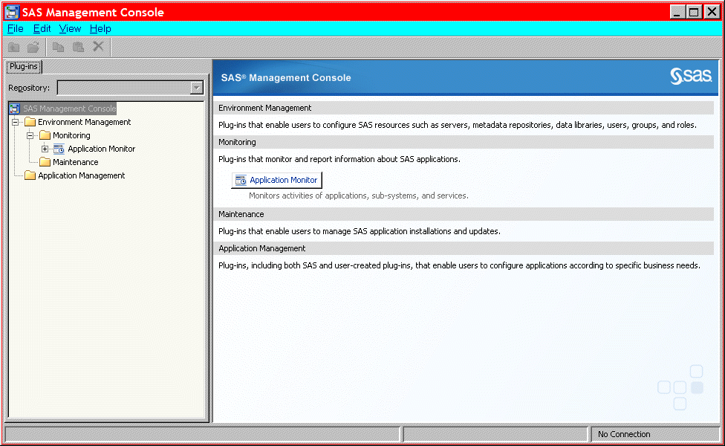
Display 1. Former Main Interface for SAS Management Console
Use captions for displays.

Subhead A Level <heading 2>
This is subtopic for the above main topic (Heading 1).
If you need to include SAS output, this is an example of how to present it:
Output 1 shows an example of how to present output.

CREATE TABLE ALLACCTX(SourceSystem varchar(4),
cctnum numeric(18,5) CONSTRAINT "ALLACCT_PK" PRIMARY KEY,
ccttype numeric(18,5),balance numeric(18,5),clientid numeric(18,5),
losedate date,opendate date,primary_cd numeric(18,5),status varchar(1))

Output 1. Output from a CREATE TABLE Statement
Use captions for output. Note that output is the same font as source code, but it is in a box. (Not a Text box.)
Continuation of paper body; after output.

Subhead A Level <heading 2>
This is the paper body.

Subhead B Level <Heading 3>

Conclusion <heading 1>
The conclusion summarizes your paper and ties together any loose ends. You can use the conclusion to make any final points such as recommendations, predictions, or judgments.
This is the text for the paper’s conclusion.

References <heading 1>
This section is not required. Use a bulleted list if you have more than one reference. The references below are examples and do not cover the spectrum of examples that might be included. The important thing is to be consistent in the formatting and organization of your references. If you prefer, you can follow a bibliographic approach such as the American Psychological Association (http://www.apastyle.org/manual/index.aspx ) or the American Statistical Association (http://pubs.amstat.org/page/styleguide ).
This is the text for the references.
Book <Author name: last name, first name>. <Copyright date>. <Book title>. <page numbers>. <City, State of Publisher>: <Publisher name>
Journal article <Author name: last name, first name>. <Copyright date>. “<Article title>.” <Journal title>. <page numbers>. <City, State of Publisher>: <Publisher name>
Article in conference proceeding <Author name: last name, first name>. <Copyright date>. “<Article title>.” <Title of proceedings such as Proceedings of the SAS Global 2015 Conference>. <City, State of Publisher>: <Publisher name> Optional: You can add a URL to access available online copies. For example: Available at http://support.sas.com/resources/papers/proceedings09/TOC.html.
Web site <Author name: last name, first name>. “<Title>.” <Source>. <Date>. Available at <URL>.

Acknowledgments <heading 1>
This section is not required.
This is the text for the acknowledgments.

Recommended Reading <heading 1>
This section is not required. Use a bulleted list if you have more than one reference. This is the format for recommended reading.
- Base SAS® Procedures Guide
- SAS® For Dummies®

Contact Information <heading 1>
In case a reader wants to get in touch with you, please provide your contact information.
Your comments and questions are valued and encouraged. Contact the author at:
Name:
Enterprise:
Address:
City, State ZIP:
Work Phone:
Fax:
E-mail:
Web:

The next two paragraphs (three lines) are required and need to be in the paper.
SAS and all other SAS Institute Inc. product or service names are registered trademarks or trademarks of SAS Institute Inc. in the USA and other countries. ® indicates USA registration.
Other brand and product names are trademarks of their respective companies.
Formatted Samples
This page has samples that you can copy into the body of your paper and adapt as necessary for your content.
Note: Delete this page before submitting your paper.
Source Code Sample
data one;
set two;
if mix(var1, var2) > 0 then do;

List: Numbered or Ordered
- numbered list item
- numbered list item
- numbered list item
List: Bulleted or Unordered
- This is a sample bulleted list item.
- This is a sample bulleted list item.

Output Sample

CREATE TABLE ALLACCTX(SourceSystem varchar(4),
cctnum numeric(18,5) CONSTRAINT "ALLACCT_PK" PRIMARY KEY,
ccttype numeric(18,5),balance numeric(18,5),clientid numeric(18,5),
losedate date,opendate date,primary_cd numeric(18,5),status varchar(1))

Output 2. Output from a CREATE TABLE Statement

Table Sample
Heading for Column 1 | Heading for Column 2 | Heading for Column 3 | Heading for Column 4
Table 2. Sample Table

Basic Instructions: Insert Captions, Cross-References, and Graphics
These instructions are written for MS Word 2007, 2010, and 2013. The steps are similar for MS Word 2003.
To insert a caption:
- Click References on the main Word menu.
- Click Insert Caption.
- Select the Label type you want.
- Click OK.
To insert a cross-reference:
- Click References on the main Word menu.
- Click Cross-reference.
- In the Reference type list box, select Figure, Table, Display, or Output.
- In the For which caption list, select the caption you want.
- From the Insert reference to list, select Only label and number.
To insert a graphic from a file:
- Click Insert on the main Word menu.
- Click Picture.
- In the Insert Picture dialog box, navigate to the file you want to insert.
- When the name of the file you want to insert is displayed in the File name box, click Insert.

