SAS Heatmaps in the Analysis of Real Estate Markets
Harshita Budumuru, Green Level High School, Cary, NC.

ABSTRACT

This paper purposes the use of a heat map model to display dynamic agglomeration and diffusion effects of rising house prices. We study the impact of the Covid-19 pandemic on changes in locations for housing demand. The competition for the housing market saw shifts away from densely populated areas. The pandemic influenced forces such as government intervention, changes in demand, and reductions in supply, all leading to high uncertainty of the current stage of the market. We describe the creation of heat maps as a solution to home buyers and investors. INTRODUCTION
During Covid-19, many companies questioned whether to take the risk of employees getting sick or finding a method that didn’t compromise productivity. Given these health risks, many employers had workers switch to remote working (Bartik, 2020). Many countries, including the
U.S. placed strict quarantining practices to reduce the spread of this communicable disease. The pandemic had immense pressures on the supply and demand chains. Manufacturers battled with liquidity and profitability. Companies had to make up for smaller revenues, cancelled orders, and dropping stock prices (NCBI - WWW Error Blocked Diagnostic, n.d.). In the research conducted by the Real-Time People Survey (RPS), 8.2% of employees workers remotely in Febuary of
2019 as opposed to 35.2% in the following May (Bick et al., 2020). Another survey by the National Association of Business Economists (NABE), conducted in March of 2020, stated that 45% of the firms surveyed reported to having switched its employees to remote working.

EFFECTS ON HOUSING

The pandemic also had an immediate decline of spending. Millions of JPMorgan Chase customers were considered in a microeconomic study which found that the overall card spending of these customers dropped by nearly 40% in the second half of March when the national

quarantine began (Wessel, 2022). Many restaurants and companies providing travel accommodations, along with healthcare and fuel services saw rapid drops in aggregate spending (Wessel, 2022). Therefore, a necessity to live in densely populated, urban areas where jobs and consumption amenities have agglomerated, might have declined. The pandemic has dramatically fueled the housing demand to shift from urban spheres to less dense suburbs. Evidence suggests that homes with financial growth are more likely to develop in communities that have higher access to telework-compatible jobs (Liu & Su, 2021).

EMPLOYMENT

This sharp increase in house prices is much different from the 2008 recession (Why House Prices Surged as the COVID-19 Pandemic Took Hold, n.d.). Although the pandemic caused severe unemployment during quarantine, Congress reacted to this increased economic panic by passed several measures of support including the Unemployment Insurance (UI) system (Whittaker & Isaacs, 2022). These unemployment benefits provided temporary paychecks to individuals who lost their jobs through no fault of their own (North Carolina Division of Employment Security, n.d.). This helped to stabilize the recession by increasing household incomes. In the great recession, however, homebuyers had taken on too much debt while struggling against tight lending restrictions. In addition, the Federal Reserve stepped in with quantitative easing, a process where a central bank purchases high amounts of mortgage-backed securities in order to reduce interest rates (Wessel, 2022). With a lower bound of 0% interest, these rates accommodated for a boost in the housing demand.

SUPPLY SHORTAGES

Pandemic related constraints causing disruptions in the construction of houses has placed an upper limit on the housing supply, leading to pressures on house prices (Why House Prices

Surged as the COVID-19 Pandemic Took Hold, n.d.). The U.S. faced health related threats of the pandemic along with higher tariffs on imported goods during quarantine (Tang et al., 2022).
These imported goods include many materials necessary for construction, such as lumber and foreign steel (How to Clean a Showerhead, According to an Expert, 2022). Over the past 30 years, supply has reached a plummeting point, with units estimated to be 100,000 houses below the demand (Parrott & Zandi, 2021)). In May of 2021, lumber prices saw an all time high of
$1686 per thousand board feet. The National Association of Homebuilders estimates that average house prices went up nearly $36000 to make up for these added expenses. This shortage isn’t due to a lack of trees but rather the increase in Canadian tariffs. Quarantine also limited the transportation of lumber from the mills to the dealers (Moore, n.d.). Another motive for these shortages are the increased movement towards remodeling. Staying indoors for extended periods of time has certainly motivated many to want better appliances, such as a better grill or stove.
According to the Commerce Center, furniture sales went up approximately 18.18% in June of 2021, compared to the previous year. All these factors influenced the vast chain or supply shortages (Singh, 2021).

HOUSING DEMANDS

Now, as the U.S. reaches closer to the end of the pandemic, such high inflation, bidding competition, and skyrocketing mortgage rates, are all making it more difficult for home buyers and investors to keep up with high house prices. Yet, competition isn’t declining. Houses are being sold faster than ever. According to research done by Zillow, the average home in 2020 stayed on the market for 25 days before going into contract. This being lower than 30 days in 2019 (Lyons, 2021). Although demands have been inconsistent in the past few years, a

correlation between rising house prices and higher demand is apparent. Can eager investors make the right decision while facing such high competition?

USE OF HEAT MAPS

They may be a way. Home buyers can analyze market trends using heat maps. Heat maps, also referred to as Intensity maps, are graphic models that summarize large sums of data. Each individual value is represented using a color with a different shade or hue in order to emphasis its numerical intensity. The color coded nature of such heat maps allow for great visual representations that make complex combinations of data more comprehensible in comparison to other standard analytical tools. Earlier sources of heat maps were used to display findings in bioinformatics. In the past decade, heat maps have been generated through GIS programs for various uses including population densities, crime reports, climate preditions, etc (DeBoer,
2015). However, the use of SAS generated heat maps as methods to predict real estate trends isn’t as common. This paper aims to make heat maps more accessible to non-technical users within this field.

OVERVIEW OF HEATMAPPARM STATEMENT

In SAS 9.4m3, heat maps can be programmed with HEATMAPPARM statements in the PROC SGPLOT. Heat maps can either be discrete or continuous. In a continuous version, a color gradient is developed using a single color. The gradient is generally split into “High,” “Medium,” and “Low” with darker shades relating to higher intensities. Discrete heat maps, on the other hand, use different color palettes within. While using the HEATMAPPARM statement, your SAS dataset must include 3 variables. 2 independent variables must be used to represent the x and y grids for each rectangle. The final variable is the COLORGROUP which specifies the color intensity.

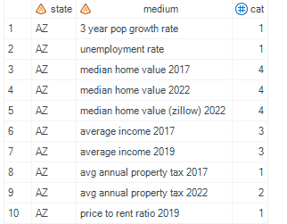

In the example dataset above, “state” accounts for the x-axis and “medium” represents the y-axis. “Cat” is the COLORGROUP where 1 has the lowest numerical intensity. The x and y bins must exist for your program to run. SAS 9.4m3 and later versions have an upper limit of 100,000 bins (SAS Help Center, n.d.). Notice how a separate observation exists for each x & y value pair. The following includes the code which corresponds to the data above.

libname real ":C\Desktop\Harshy\conf";

proc import datafile=":C\Desktop\Harshy\conf\realheat.csv" out=real1 dbms=csv replace;
getnames=yes; datarow=2;
run;

proc sgplot data=real1 /*dattrmap=Order*/;

heatmapparm x=state y=medium colorgroup=cat / outline attrid=SortOrder;
xaxis label="State" display=all ;

yaxis label=" " display=all discreteorder=data;

keylegend / location=outside poistion=right title= "Frequency";

run;

Here is the heat map that was generated using the code above.

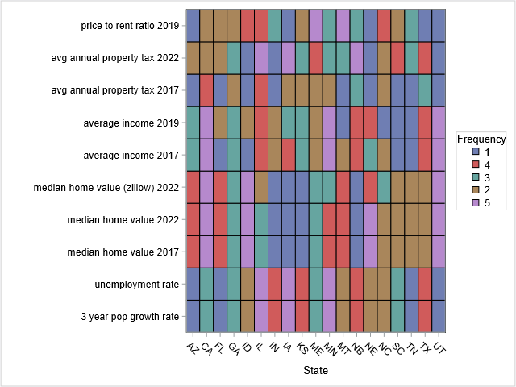

Y-AXIS PARAMETERS

This heat map compares various U.S. states to relevant parameters. Here are some of the parameters that were measured: price to rent ratio, unemployment rate, median home value, property tax rates, and population growth. A price to rent ratio is a ratio of home prices to the annual rent in a given area. It is used as a benchmark to estimate whether it is cheaper to own or rent. If the price to rent ratio is higher, then home prices are more expensive than rent prices so it makes more sense to rent than own. The unemployment rate of an area is extremely important, especially given the circumstances brought on by the pandemic, because higher unemployment

begins a cycle of less affordability and thus less demand. Less demand leads to more supply, causing prices to go down. The median home value is a great indicator of where the current market. A rising median home price is indicative of a seller’s market while the opposite is true for a buyer’s market. Here, we have presented the median home value in 2017 and 2022 along with the price placed by Zillow to show changing conditions and factors such as demand and inflation. We have also listed the average income in 2017 and 2019 to present the changes that have occurred over the pandemic. Investors can see how an increased income can lead to
increased consumption and a resulting increase in owning or renting of properties. Property taxes are important because property taxes tend to increase when a county or state is increasing (or facing rapid population growth) in order for the government to be able to afford certain expenses such as schooling and other funds. For example, New Jersey has around three times the property taxes than in North Carolina. This is because certain urban centers in New Jersey have been established for far longer than in North Carolina. However, the Research Triangle Park area and Wake County have higher property taxes because of the booming markets. Lastly, the 3 year population growth rate illustrates how people tend to build more houses in proximity of larger population growth. This also causes price spike, especially now that the pandemic is making people lean toward urban sprawl into less dense areas. These parameters can be used to gain a basic understanding of market trends. The following heat maps apply a different approach.

Figure 2. Code

libname real " real ":C\Desktop\Harshy\conf"; ";

proc import datafile=" real ":C\Desktop\Harshy\conf";

\real2.csv"

out=real2 dbms=csv replace; getnames=yes;
datarow=2;

run;

proc sgplot data=real2 ;

heatmapparm x=age y=income colorgroup=percent / outline attrid=SortOrder;
xaxis label="Age group" display=all ;

yaxis label="Median Household Income" display=all discreteorder=data;
keylegend / location=outside poistion=right title= "Frequency";

run;

Figure 2. Output

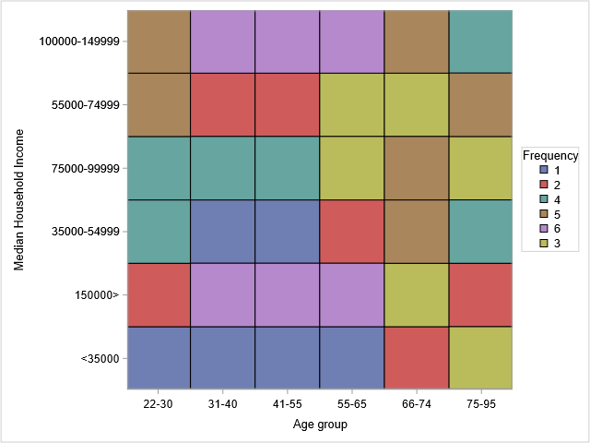

OBSERVATIONS

Based on the data gathered, certain observations could be made. Ages 22 through 65 have a low frequency (1 = blue) of median household incomes to be less than $35000. Therefore, one could predict that the working class population is least likely to have a low median income. On the other hand, ages 31 through 65 have the highest frequency (6 = purple) of median household

incomes being greater than $100,000 indicating that the working class population most likely makes 6 figures.

Figure 3. Data

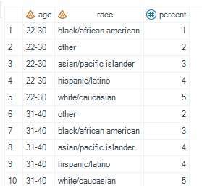

Figure 3. Code

libname real ":C\Desktop\Harshy\conf";

proc import datafile=" real ":C\Desktop\Harshy\conf\real3.csv" out=real3 dbms=csv replace;
getnames=yes; datarow=2;
run;

proc sgplot data=real3 ;

heatmapparm x=age y=race colorgroup=percent / outline attrid=SortOrder;
xaxis label="Age Group" display=all ;

yaxis label="Race" display=all discreteorder=data;

keylegend / location=outside poistion=right title= "Frequency";

run;

Figure 3. output

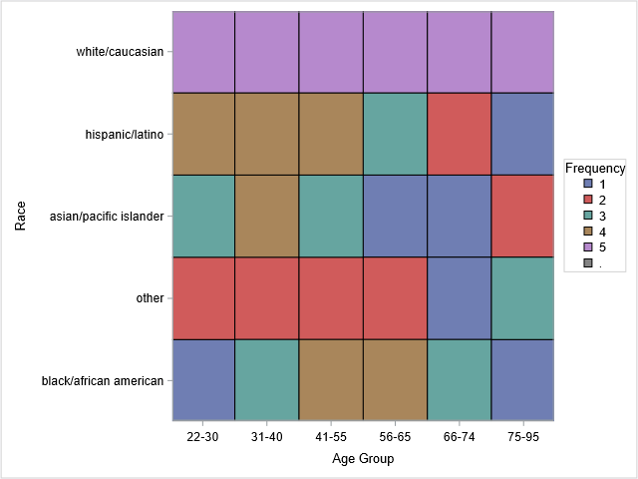

OBSERVATIONS

Given this heat map which compares age groups of all U.S. residents to their respective races, it can be seen that the majority of the U.S. population consists of whites/caucasians regardless of their age. The U.S. also has a high population density of hispanic/latino populations of ages 22 through 55.

CONCLUSION

In a world where the economy is constantly changing to accommodate for consumer demand, finding ways to summarize and compare large quantities of data concurrently is extremely vital. SAS provides a great platform for heat maps to achieve such a goal. Whether this is your first experience using SAS to create heat maps or you are seeking a new completely new method to analyze the data you gathered on real estate trends, the examples provided in this paper should steer you in the right direction.

Citations

Bartik, A. W. (2020, June 29). What Jobs are Being Done at Home During the Covid-19 Crisis?

Evidence from Firm-Level Surveys. NBER. Retrieved September 26, 2022, from https://www.nber.org/papers/w27422
Bick, A., Blandin, A., & Mertens, K. (2020, July). Work from Home After the COVID-19 Outbreak. Federal Reserve Bank of Dallas, Working Papers, 2020(2017). https://doi.org/10.24149/wp2017r1
DeBoer, M. (2015, November 12). Understanding the Heat Map. Cartographic Perspectives, 80, 39–43. https://doi.org/10.14714/cp80.1314
How to clean a showerhead, according to an expert. (2022, June 15). Home Guides | SF Gate.

Retrieved September 26, 2022, from https://homeguides.sfgate.com/how-clean-showerhead-13771618.html
Liu, S., & Su, Y. (2021, October). The impact of the COVID-19 pandemic on the demand for density: Evidence from the U.S. housing market. Economics Letters, 207, 110010. https://doi.org/10.1016/j.econlet.2021.110010
Lyons, J. (2021, November 2). What Is the Average Time to Sell a House? Home Sellers Guide.

Retrieved September 26, 2022, from https://www.zillow.com/sellers-guide/average-time-to-sell-a-house/
Moore, A. (n.d.). Ask an Expert: Why Is There a Lumber Shortage? College of Natural Resources News. Retrieved September 26, 2022, from https://cnr.ncsu.edu/news/2021/05/lumber-shortage/
NCBI - WWW Error Blocked Diagnostic. (n.d.). Retrieved September 26, 2022, from https://www.ncbi.nlm.nih.gov/pmc/articles/PMC8596861/

North Carolina Division of Employment Security. (n.d.). DES: Unemployment Benefit Basics.

Retrieved September 26, 2022, from

https://des.nc.gov/apply-unemployment/unemployment-benefit-basics

Parrott, J., & Zandi, M. (2021, March). Overcoming the Nation’s Daunting Housing Supply Shortage. Retrieved August 15, 2022, from
https://www.moodysanalytics.com/-/media/article/2021/Overcoming-the-Nations-Housin g-Supply-Shortage.pdf
SAS Help Center. (n.d.). Retrieved September 26, 2022, from https://documentation.sas.com/doc/en/pgmsascdc/9.4_3.5/grstatproc/p0y94pnvxskvkmn1 9u7sx2j043lq.htm
Singh, D. (2021, July 20). The Other Housing Shortage: Appliances And Furniture. Bankrate.

Retrieved September 26, 2022, from https://www.bankrate.com/mortgages/pandemic-appliance-shortage/
Tang, W., Hu, J., Reivan Ortiz, G. G., Mabrouk, F., & Li, J. (2022, April 26). Research on the Impact of COVID-19 on Import and Export Strategies. Frontiers in Environmental Science, 10. https://doi.org/10.3389/fenvs.2022.891780
Wessel, E. M. A. D. (2022, March 9). What did the Fed do in response to the COVID-19 crisis?

Brookings. Retrieved September 26, 2022, from https://www.brookings.edu/research/fed-response-to-covid19/
Whittaker, J. M., & Isaacs, K. P. (2022, June 24). How Did COVID-19 Unemployment Insurance Benefits Impact Consumer Spending and Employment? Congressional Research Service Reports. Retrieved August 11, 2022, from https://crsreports.congress.gov/product/pdf/IF/IF12143

Why House Prices Surged as the COVID-19 Pandemic Took Hold. (n.d.). Dallasfed.org.

Retrieved September 26, 2022, from https://www.dallasfed.org/research/economics/2021/1228.aspx

